**Theme Changer**

1. **Task Description**

Implement a global app theme switcher in React using the Context API and local storage to manage user preferences for light and dark modes. Create a ThemeContext that provides the current theme and a toggle function, leveraging a custom hook for local storage. Include a ThemeSwitcher component to allow users to switch themes, dynamically updating the body class for styling. Use separate CSS files for light and dark themes to ensure a consistent user experience across sessions.

1. **Task Output Screenshot**

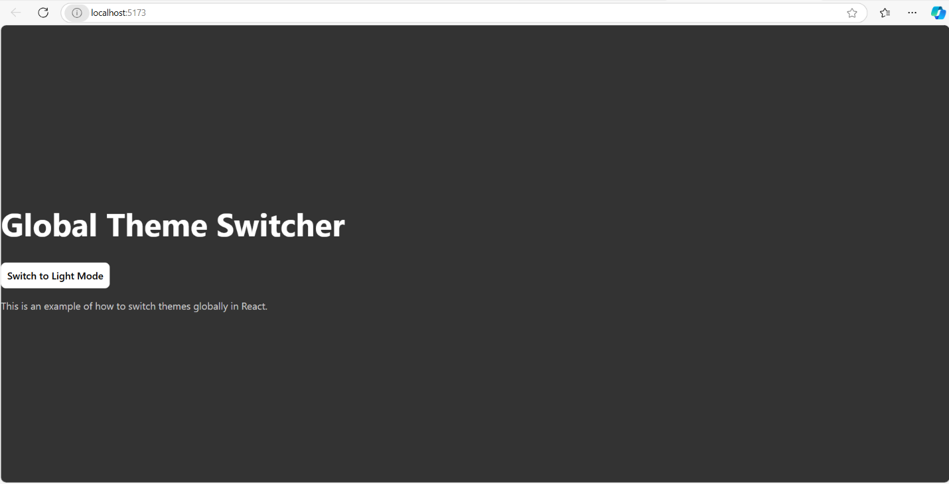

1. **Widget/Algorithm Used In Task**

• **Context API**: Utilizes React's Context API to create a centralized state for managing the theme, allowing any component in the application to access and update the current theme easily.

• **Local Storage**: Implements a custom hook to store the user's theme preference in local storage, ensuring that the selected theme persists across page reloads and sessions.

• **Theme Toggle Function**: Contains a function that switches between light and dark themes by updating the context state, which in turn affects the body class for styling.

• **Dynamic CSS Application**: Applies CSS classes based on the current theme, allowing for responsive styling changes that reflect the user's choice immediately throughout the application